ESCUELA COLOMBIANA DE INGENIERIA JULIO GARAVITO
LUIS ALEJANDRO ARDILA GONZALEZ
DDYA
SEMANA 5

- Poisonous plants:
https://www.hackerrank.com/challenges/poisonous-plants/problem?h_r=internal-search

#!/bin/python3

import math
import os
import random
import re
import sys

#
# Complete the 'poisonousPlants' function below.
#
# The function is expected to return an INTEGER.
# The function accepts INTEGER_ARRAY p as parameter.
#

def poisonousPlants(p):
pila = []
max_dias = 0

for planta in p:
dias = 0

while pila and planta <= pila[-1][0]:
dias = max(dias, pila.pop()[1])

if not pila:
dias = 0
else:
dias += 1

max_dias = max(max_dias, dias)
pila.append((planta, dias))

return max_dias

if __name__ == '__main__':
fptr = open(os.environ['OUTPUT_PATH'], 'w')

n = int(input().strip())

p = list(map(int, input().rstrip().split()))

result = poisonousPlants(p)

fptr.write(str(result) + '\n')

fptr.close()

-DIAGRAMA DE FLUJO:
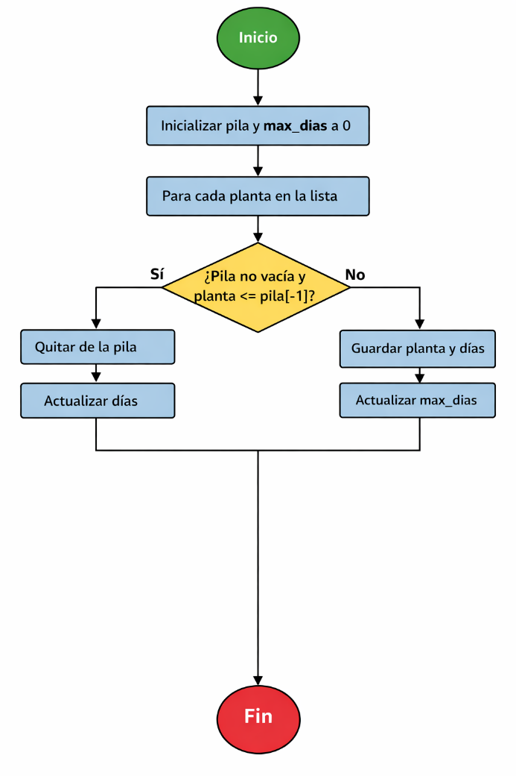

- Two stacks:
https://www.hackerrank.com/challenges/queue-using-two-stacks/problem?isFullScreen=true

pila_entrada = []
pila_salida = []

consultas = int(input())

for i in range(consultas):
operacion = input().split()

if operacion[0] == "1":
pila_entrada.append(int(operacion[1]))

elif operacion[0] == "2":
if len(pila_salida) == 0:
while len(pila_entrada) > 0:
pila_salida.append(pila_entrada.pop())
pila_salida.pop()

elif operacion[0] == "3":
if len(pila_salida) == 0:
while len(pila_entrada) > 0:
pila_salida.append(pila_entrada.pop())
print(pila_salida[-1])

-DIAGRAMA DE FLUJO:
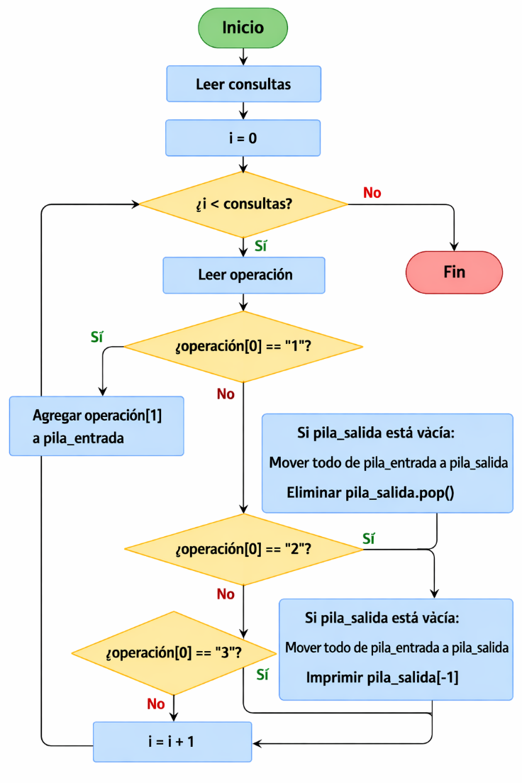

- And Xor:
https://www.hackerrank.com/challenges/and-xor-or/problem?isFullScreen=true

#!/bin/python3

import math
import os
import random
import re
import sys

#
# Complete the 'andXorOr' function below.
#
# The function is expected to return an INTEGER.
# The function accepts INTEGER_ARRAY a as parameter.
#

def andXorOr(a):
pila = []
maximo = 0

for numero in a:

while pila:
resultado = numero ^ pila[-1]
maximo = max(maximo, resultado)

if pila[-1] > numero:
pila.pop()
else:
break

pila.append(numero)

return maximo

if __name__ == '__main__':
fptr = open(os.environ['OUTPUT_PATH'], 'w')

a_count = int(input().strip())

a = list(map(int, input().rstrip().split()))

result = andXorOr(a)

fptr.write(str(result) + '\n')

fptr.close()

DIAGRAMA DE FLUJO:
